**How to Convert HTML to PDF in a Linux Docker Container using ASP.NET Core**

The Syncfusion® [HTML to PDF converter](https://www.syncfusion.com/pdf-framework/net/html-to-pdf) is a [**.NET PDF library**](https://www.syncfusion.com/document-processing/pdf-framework/net-core) for converting webpages, SVG, MHTML, and HTML to PDF using C#. It is reliable and accurate. The result preserves all graphics, images, text, fonts, and the layout of the original HTML document or webpage. Using this library, you can convert HTML to PDF in Linux [docker](https://www.docker.com/why-docker) container.

Steps to convert HTML to PDF in Linux docker container:

**1.Create an ASP.NET Core MVC Application**: Initiate a project using ASP.NET Core Model-View-Controller pattern.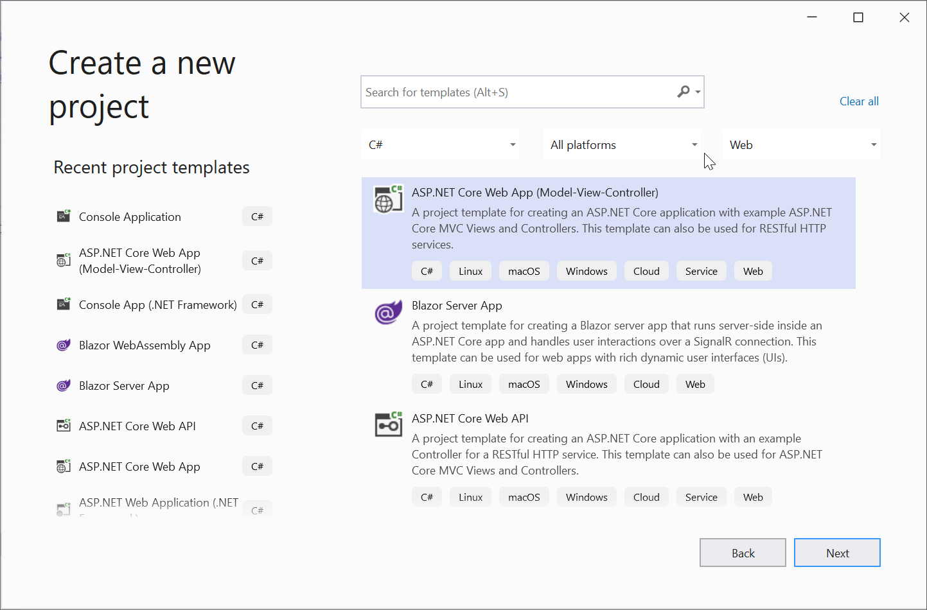

Enable Docker support and select Linux as the target operating system.

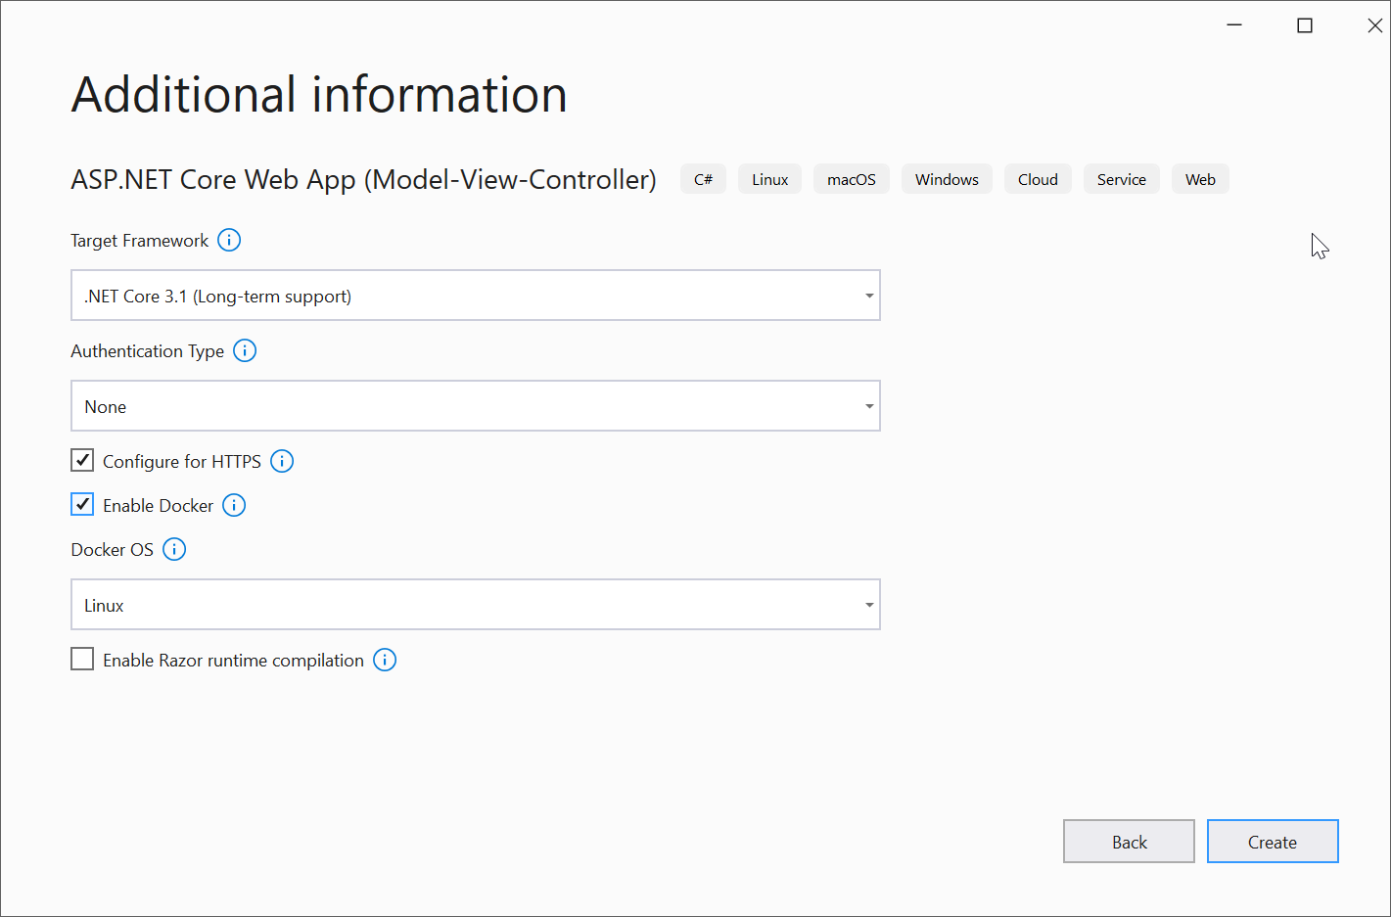

2. **Install Syncfusion Package**: Add [Syncfusion.HtmlToPdfConverter.Net.Linux](https://www.nuget.org/packages/Syncfusion.HtmlToPdfConverter.Net.Linux/) from NuGet as a project reference.

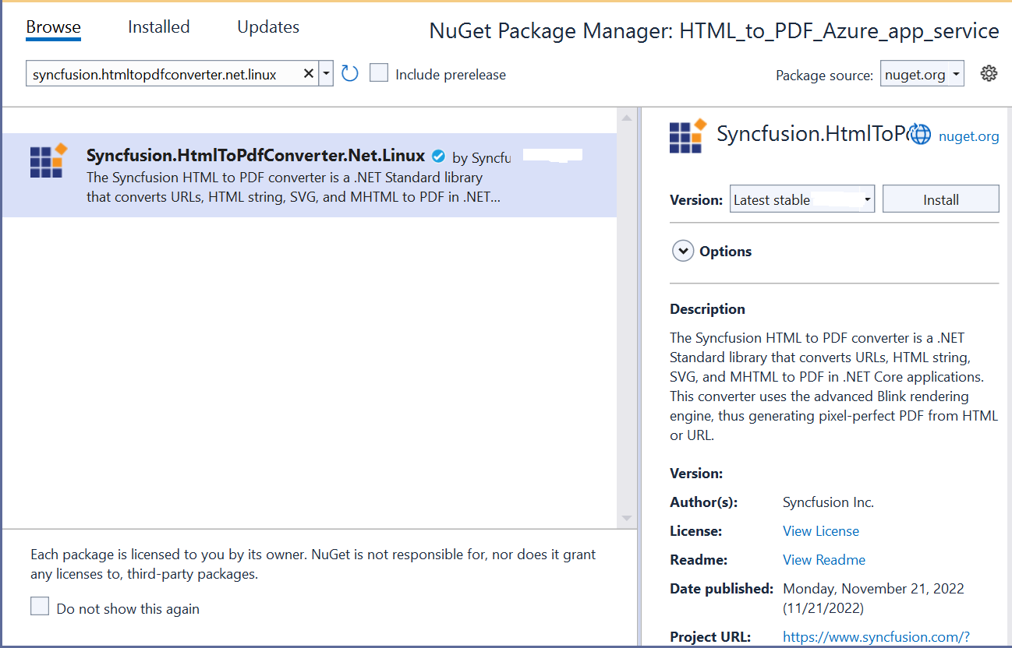

**3.Configure the Docker file**: Include the following snippet in your Docker file to ensure all necessary dependencies are installed

|  |
| --- |
| RUN apt-get update && \  apt-get install -yq --no-install-recommends \  libasound2 libatk1.0-0 libc6 libcairo2 libcups2 libdbus-1-3 \  libexpat1 libfontconfig1 libgcc1 libgconf-2-4 libgdk-pixbuf2.0-0 libglib2.0-0 libgtk-3-0 libnspr4 \  libpango-1.0-0 libpangocairo-1.0-0 libstdc++6 libx11-6 libx11-xcb1 libxcb1 \  libxcursor1 libxdamage1 libxext6 libxfixes3 libxi6 libxrandr2 libxrender1 libxss1 libxtst6 \  libnss3 libgbm1 |

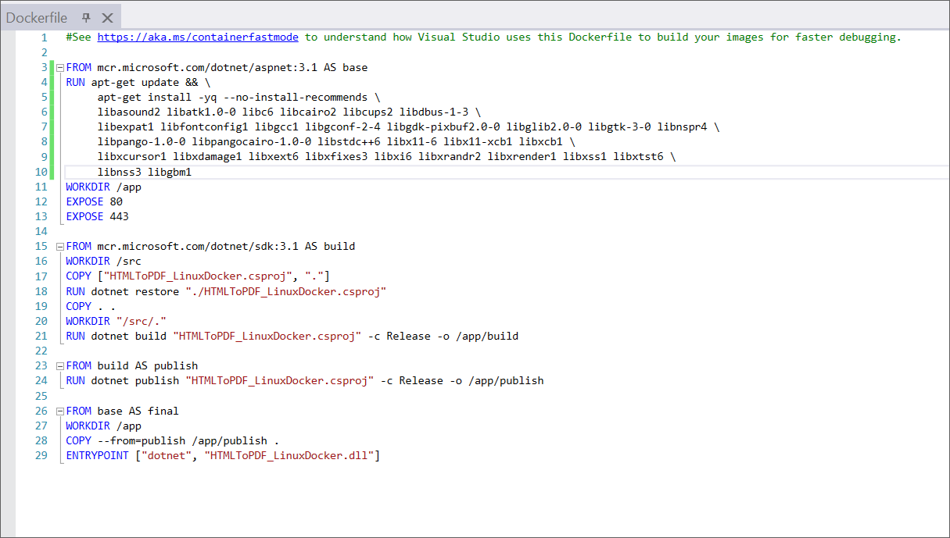

**4.Add Export to PDF Button**: In your **index.cshtml**, add an "Export To PDF" button using the following code

|  |
| --- |
| <div class="btn">  @{ Html.BeginForm("ExportToPDF", "Home", FormMethod.Post);  {  <input type="submit" value="Export To PDF" class=" btn" />  }}  </div> |

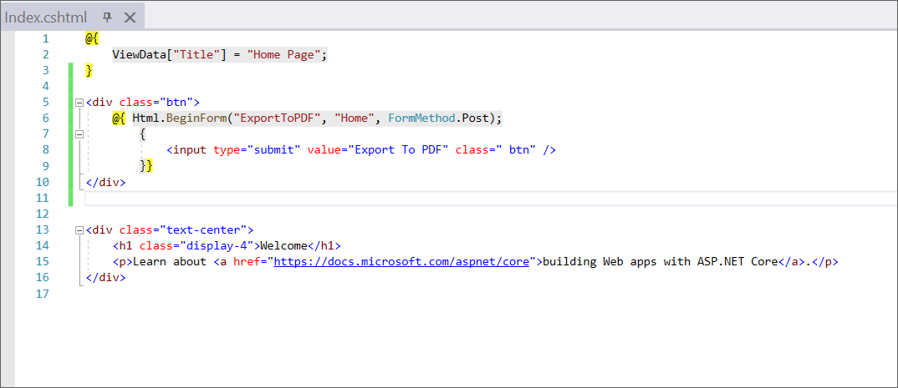

5. **Implement Conversion Logic in Controller**: Use the Syncfusion library in your controller to handle the conversion

|  |
| --- |
| using Syncfusion.HtmlConverter;  using Syncfusion.Pdf;  using System.IO;  public ActionResult ExportToPDF()  {  // Initialize the HTML to PDF converter  HtmlToPdfConverter htmlConverter = new HtmlToPdfConverter();  // Set Blink rendering engine settings  BlinkConverterSettings settings = new BlinkConverterSettings();  // Add command-line arguments to support conversion in sandboxed environments (Linux Docker, Azure, etc.)  settings.CommandLineArguments.Add("--no-sandbox");  settings.CommandLineArguments.Add("--disable-setuid-sandbox");  // Assign the settings to the converter  htmlConverter.ConverterSettings = settings;  // Convert the webpage URL to a PDF document  PdfDocument document = htmlConverter.Convert("https://www.syncfusion.com");  // Save the PDF document to a memory stream  MemoryStream stream = new MemoryStream();  document.Save(stream);  // Return the PDF file as a downloadable response  return File(stream.ToArray(), System.Net.Mime.MediaTypeNames.Application.Pdf, "Sample.pdf");  } |

6. **Run your Project**: Build and execute your application within the Docker container. The setup will automatically pull the necessary Linux Docker image to enable the functionality.

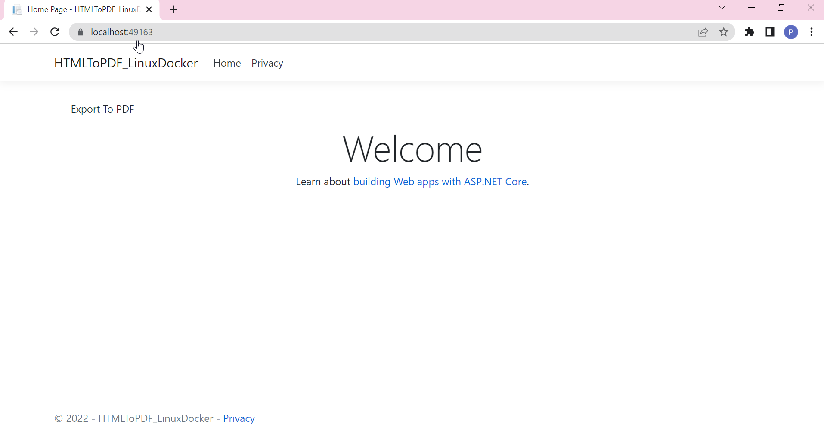

By executing the program, the output PDF document will be generated as shown below:

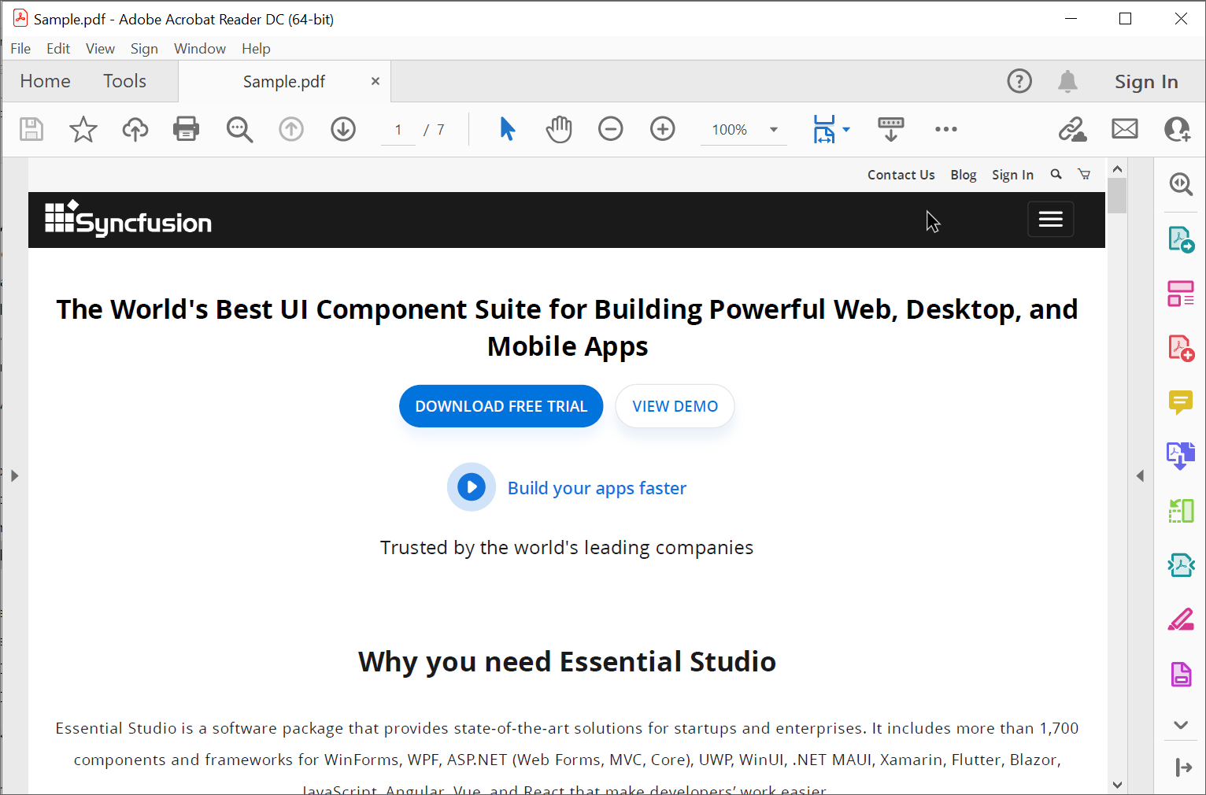

A complete work sample for converting a HTML to PDF in Linux docker container can be downloaded from [HTMLtoPDF_LinuxDocker.zip](https://www.syncfusion.com/downloads/support/directtrac/general/ze/HTMLToPDF_LinuxDocker1596837150).

Take a moment to explore the [documentation](https://help.syncfusion.com/file-formats/pdf/converting-html-to-pdf), where you can learn how to convert HTML pages to PDF documents, along with various customization options and features.

**Conclusion**

I hope you enjoyed learning about how to convert HTML to PDF in Linux docker container in ASP.NET Core PDF.

You can refer to our [**ASP.NET Core PDF**](https://www.syncfusion.com/document-processing/pdf-framework/net-core) [**feature tour**](https://www.syncfusion.com/document-processing/excel-framework/net-core) page to know about its other groundbreaking feature representations and [**documentation**](https://help.syncfusion.com/file-formats/pdf/create-pdf-file-in-asp-net-core), and how to quickly get started for configuration specifications. You can also explore our [**ASP.NET Core PDF**](https://ej2aspnetcore.azurewebsites.net/aspnetcore/pdf/default#/bootstrap5) [**example**](https://ej2.syncfusion.com/aspnetcore/PDF/Default?_gl=1*quk35i*_ga*MjkzODA3NDIuMTY4MjQwOTYyOA..*_ga_WC4JKKPHH0*MTY5MDI2MjM0NS4yNDEuMS4xNjkwMjYyOTc1LjU0LjAuMA..#/bootstrap5) to understand how to create and manipulate data.

For current customers, you can check out our components from the [**License and Downloads**](https://www.syncfusion.com/sales/teamlicense) page. If you are new to Syncfusion®, you can try our 30-day [**free trial**](https://www.syncfusion.com/downloads/aspnetcore-js2)to check out our other controls.

If you have any queries or require clarifications, please let us know in the comments section below. You can also contact us through our [**support forums**](https://www.syncfusion.com/forums), [**Direct-Trac**](https://support.syncfusion.com/create), or [**feedback portal**](https://www.syncfusion.com/feedback/aspnet-core?control=pdf). We are always happy to assist you!